**Object Oriented Programming**

**Class & Objects:-**

**Example:**

public class Main {

// main Method

public static void main(String[] args) {

Employee emp1 = new Employee();

System.out.println(emp1.name);

emp1.printName();

String empName = emp1.getName();

System.out.println(empName);

}

}

class Employee {

String name = "Chandan Kumar";

String getName() {

return this.name;

}

void printName() {

System.out.println(this.name);

}

}

**Output:**

Chandan Kumar  
Chandan Kumar  
Chandan Kumar

**Constructor**

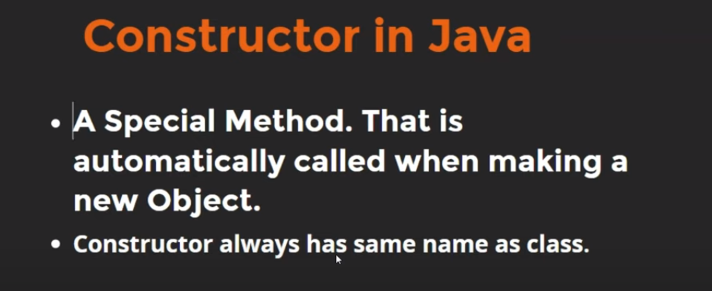

**Example:**

public class Main {

// main Method

public static void main(String[] args) {

String name = "Chandan Kumar";

Person per1 = new Person(name);

}

}

class Person {

// This is constructor which automatically get called as we create its object.

Person(String myName){

System.out.println("Constructor Called");

System.out.println(myName);

}

}

**Output:**

Constructor Called  
Chandan Kumar